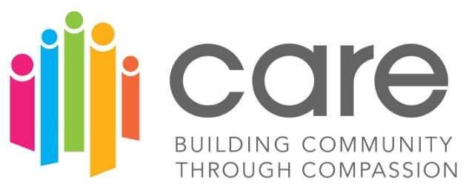

What is the CARE Movement?
CARE stands for: Compassion, Appreciation, Resilience & Empowerment

Snohomish County is committed to building restorative trauma informed organizations. Over the last three years, we have trained over 45 organizations to become designated Restorative Trauma Informed CARE sites. The vision for this partnership is for all Snohomish County residents to thrive in an equitable, sustainable environment that cultivates relationships and a strong feeling of belonging.
We have engaged our local hospital, all our community mental health agencies, all the YMCA’s, Boys and Girls Clubs and many others ranging from pre-school to older adults. The goal is to build community resiliency, increase collaboration across agency partners and strengthen the overall well-being of our community. The CARE Community Trauma Informed Principles:
Safety –​
Building relationships with others based on mutual respect and inclusion of all individuals. The goal is to promote a secure, safe, physically and emotionally, environment by building positive relationships that build resiliency for all in each interaction.​

Trustworthiness & Transparency-​
Fostering positive relationships based on trust and honesty. Share as much information as possible, relational.​
​
Peer Support-​
Identifying common concerns within the community and engaging in collective problem solving. This means recognizing and actively working towards solving the needs of every individual.​
​
Collaboration and Mutuality-​
Recognizing the importance of all roles within the organization and developing equal opportunities for decision making. Best practice is to collaborate with community members, families, and organizations within Snohomish County to promote trauma informed principles and systems of care.

Empowerment, Voice, and Choice-​
Recognizing that every person’s experience is unique and requires an individualized approach. Create opportunities and systems that empower all individual’s voice and choice. Seek staff and consumers input.​
​
Resiliency-​
Building resiliency by modeling compassion and regulation with each interaction and by providing skills and protective factors. Providing the opportunity to promote recovery and the ability to bounce back from adverse conditions. ​
​
Cultural, Historical, Gender issues-​
Appreciating and celebrating the differences and each individual’s unique experiences by practicing cultural competency. Implementing a competency lens of cultural, historical and gender issues in your daily work.​

CARE Designated Organizations:
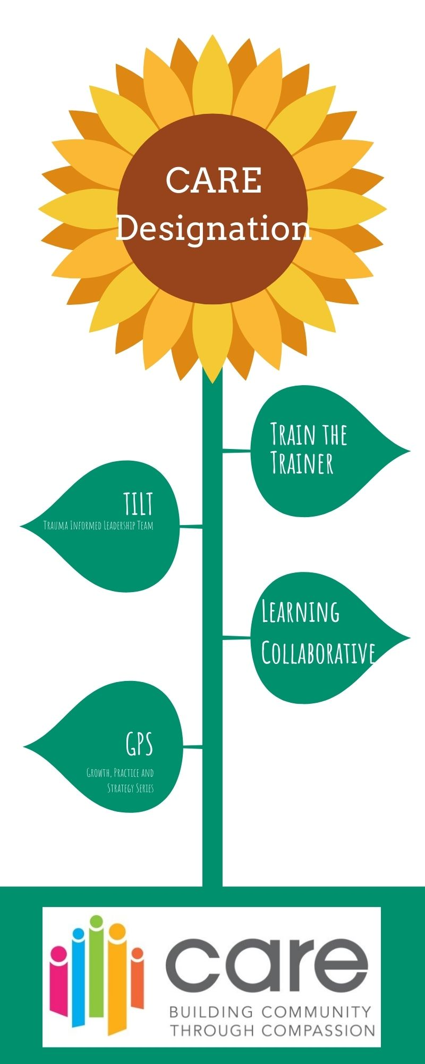
Community organizations that demonstrate that trauma-informed principles are embedded thought the organizations practices and policies. These organizations have participated in the Train the Trainer process and have formed Trauma Informed Leadership Teams
Train the Trainer:
What that means is at least two staff from each organization have become trainers for their organization and have committed to train their entire organization on Trauma Informed Care , Adverse Childhood Experiences, Self-Care, Secondary Traumatic Stress, Resiliency, and Trauma 101 with a framework that embeds Restorative Practices and Equity.
Trauma Informed Leadership Team (TILT):
The Trauma Informed Leadership Team (TILT) is a principal-driven, accountable group, working in the spirit of trauma-informed principles. The goal of the TILT is to review, shape, and lead the paradigm shift to embed trauma informed principles into policies, procedures, and practices within your organization. The TILT leads the identification, adoption and sustainability plans while building on the organizations strengths, aligning with the organization culture and centering on equity.
Learning Collaborative:
Learning Collaborative are offered for each cohort of Train the Trainers (TOT). For the first year following training, it is recommended that the TOT’s attend regularly and consistently. These groups meet monthly to provide on-going support, learning and problem-solving. The goal is for organizations to participate on an on-going basis in order to maintain CARE certification as the learning process in continuous. These collaborative are led by Laura Mote and Liza Patchen-Short.
Care TILT GPS (Growth, Practice and Strategy)
This is a learning series that uses a quality improvement and peer learning framework to provide established TILT teams with tools, resources, strategies and peer learning to advance trauma-informed, restorative work within their organization. TILTs commit to attending a total of 3 session that followed by an “action period” when TILTs apply concepts and tools to advance their trauma-informed, restorative practice or policy focus area of their choosing. During the learning series each TILT also received technical assistance and coaching to support their work. This is an optional opportunity for organizations wanting to work specifically on a project that will deepen their restorative, trauma informed work.

